**Masal Website Latest Changes**

**Note**

1. **Red Colour for NOT DONE.**
2. **Green Colour for DONE.**

**Points**

1. Product page has to be exactly same including the pin this style, Social platform share, find store button 100% has to be same as Sophia Tolli product details page including zooming the image.
   1. URL design {URL}/collection/StyleNumber
   2. Facebook share does not work
   3. Pinterest share does not work
   4. Twitter share does not work
   5. Email share does not work
2. Where to Buy page does not match with sophiatolli Site.
   1. Map must be larger as Sophiatolli
   2. Search city ,state or post code
   3. Get Direction is now working
   4. Phone number is now correct
   5. Website Facebook and Instagram links now working without https.
3. Real Bride (Masal Wedding) Page
   1. URL Design is different
   2. Change Our Bride to Our Models
   3. Change Retailer Bride to Real Weddings
4. About Us Page is Missing
5. Please add @masalaustralia Instagram on front page not @twobirdsbridal
   1. Not name only, the front Instagram module has to work and get updated whenever we update masalaustralia Instagram page.
6. Sophiaolli website has menu item s that list Silhouettes under wedding dresses section to be able to do that, we must have the same. (You can see that sophiatolli has not this item and we don’t have wedding dresses page in our website)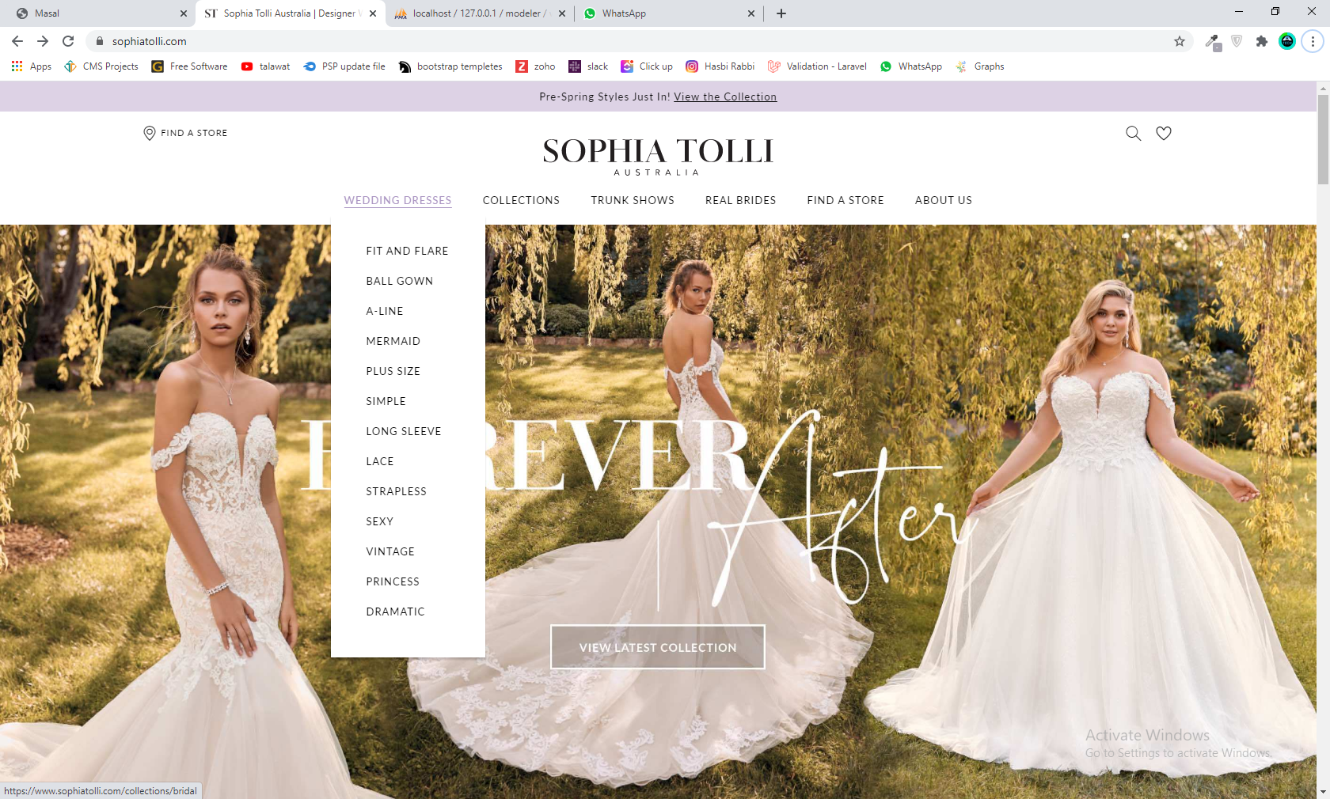
7. Seo should be define as above website
8. Become a retailer page, Name of contact should be Business name and we should have contact name so we can use that on retailer list.